Arzu Tosayeva,Minf 4/5,Database Management Systems,Blood Donation Project 

**Introduction:**

**General Information:**

**Er_Diagram :**

**References :**

**Introduction:** Each day, thousands of people provide compassionate care to those in need. Blood donation is a voluntary procedure that can help save the lives of others. There are several types of blood donation, which help meet different medical needs.This project is based on hospital and its staff data which is directly focused on serving donors and patients.

**General Information:**

As a database management system Oracle SQL Developer was used. For the project joins,views,subqueries,update,delete,insert,select,constraints,alter operations used in different kind of purposes.

**ER diagram**

An entity–relationship model describes interrelated things of interest in a specific domain of knowledge. A basic ER model is composed of entity types and specifies relationships that can exist between entities.

Explanation:

allPeople describes all information about people. This table is the biggest and most related table of system. Donor table keeps recording of details of donors such as (weight,height,gender and blood type). Patient table holds essential information about people who need donation. Nurse table is responsible for giving detailed information about nurses and their experiences. Pre_exam table holds important records of donors which are very essential during the transfusion process. Donation_types and Donation tables are related with each other with donation type. Several types of donation should have id,amount and etc.

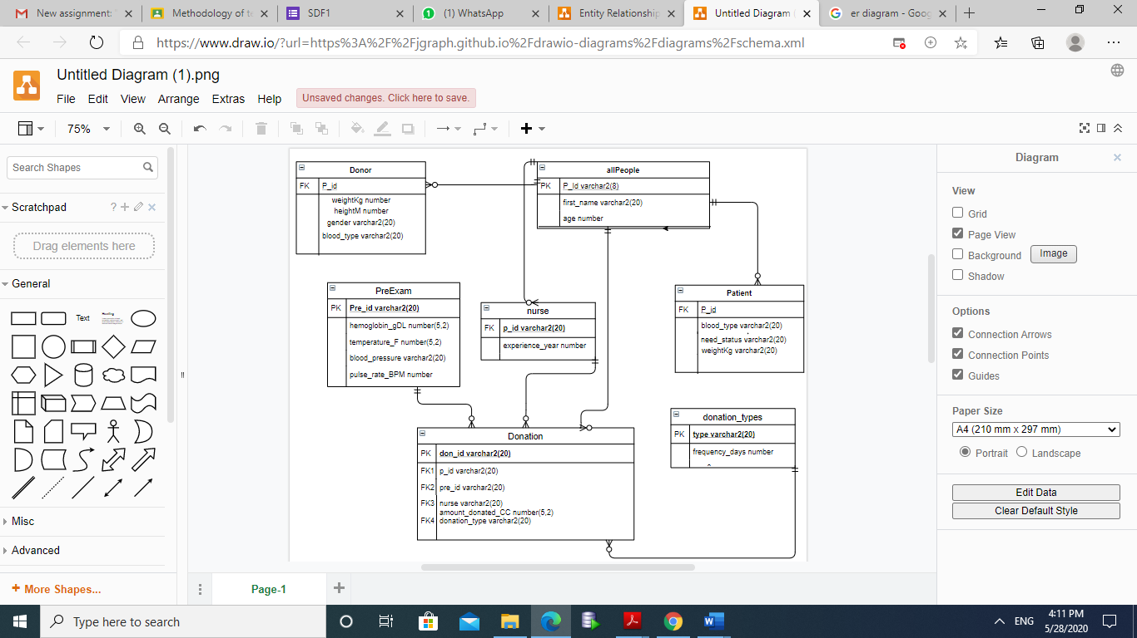

Create table allPeople(

P_Id varchar2(8) primary key,

first_name varchar2(20) not null,

last_name varchar2(20) not null,

age number not null);

create table donor(

P_id varchar2(20) not null,

constraint p_id_don_peop foreign key(p_id)

references allPeople(p_id),

blood_type varchar2(20) not null,

weightKg number not null,

heightM number not null,

gender varchar2(20), check(gender='M' or gender='F'));

create table patient(

p_id varchar2(20) not null,

constraint p_id_patien foreign key (p_id)

references allpeople(p_id),

blood_type varchar2(20) not null,

need_status varchar2(20),check(need_status='low' or need_status='high'),

weightKg varchar2(20) not null);

create table nurse(

p_id varchar2(20),

constraint nurse_p_id foreign key (p_id)

references allpeople(p_id),

experience_year number not null);

CREATE TABLE pre_exam (

pre_id varchar2(20)primary key,

hemoglobin_gDL number(5,2) not null,

temperature_F number(5,2) not null,

blood_pressure varchar2(20) not null,

pulse_rate_BPM number not null

);

CREATE TABLE donation_types (

type varchar2(20)primary key,

frequency_days number not null

);

CREATE TABLE donation (

don_id varchar2(20) primary key,

p_id varchar2(20) not null,

constraint p_id_don foreign key(p_id)

references allpeople(p_id),

pre_id varchar2(20) not null ,

constraint don_id_d foreign key(pre_id)

references pre_exam(pre_id),

nurse varchar2(20) not null,

constraint p_i_nurse foreign key(nurse)

references allpeople(p_id),

amount_donated_CC number(5,2) not null,

donation_type varchar2(20) not null ,

constraint don_ty foreign key (donation_type)

references donation_types(type)

);

alter table donor add (nextDonationDate date);

alter table donor add (phone_number number);

--Insert--

insert into allPeople values('1p','Arzu','Tosayeva',22);

insert into allPeople values('2p','Nezrin','Elekberli',21);

insert into allPeople values('3p','Camal','Huseynov',21);

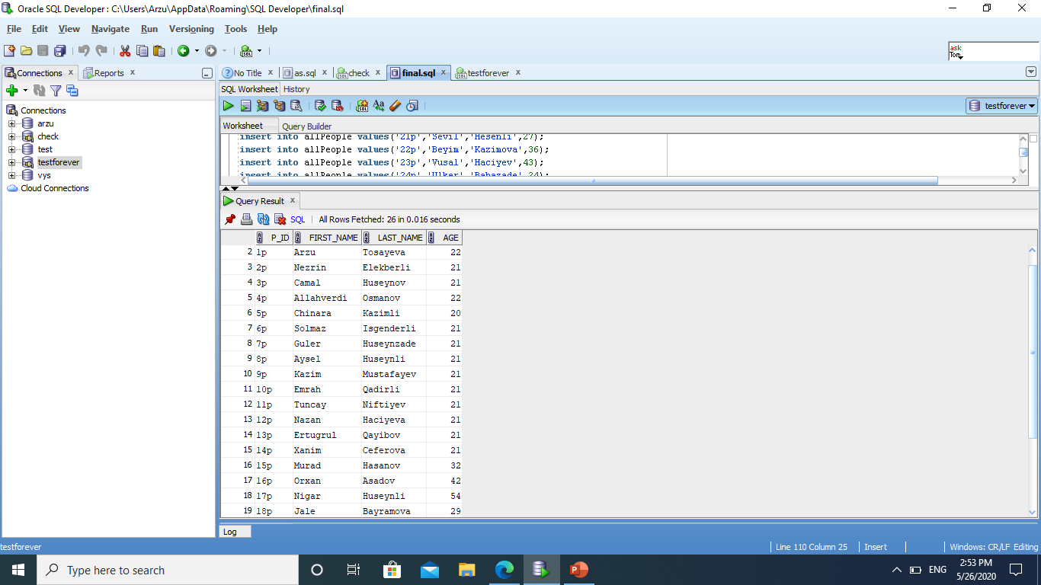

**-- O (I qrup), A (II qrup), B (III qrup) və AB (IV) --**

insert into donor values('4p','O+',60,171,'M','06-Jan-2019');

insert into donor values('7p','O-',60,168,'F','06-Feb-2019');

insert into donor values('22p','AB-',56,165,'F','08-Mar-2019');

update donor

set phone_number = 994505034568

where p_id='4p';

update donor

set phone_number = 994509834568

where p_id='7p';

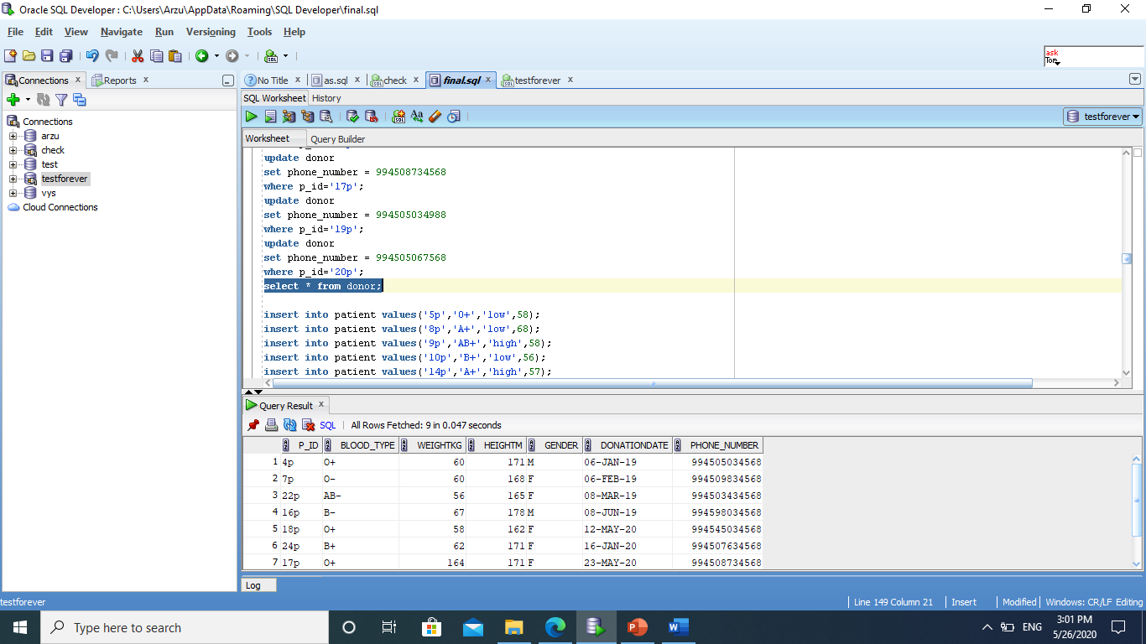

insert into patient values('5p','O+','low',58);

insert into patient values('8p','A+','low',68);

insert into patient values('9p','AB+','high',58);

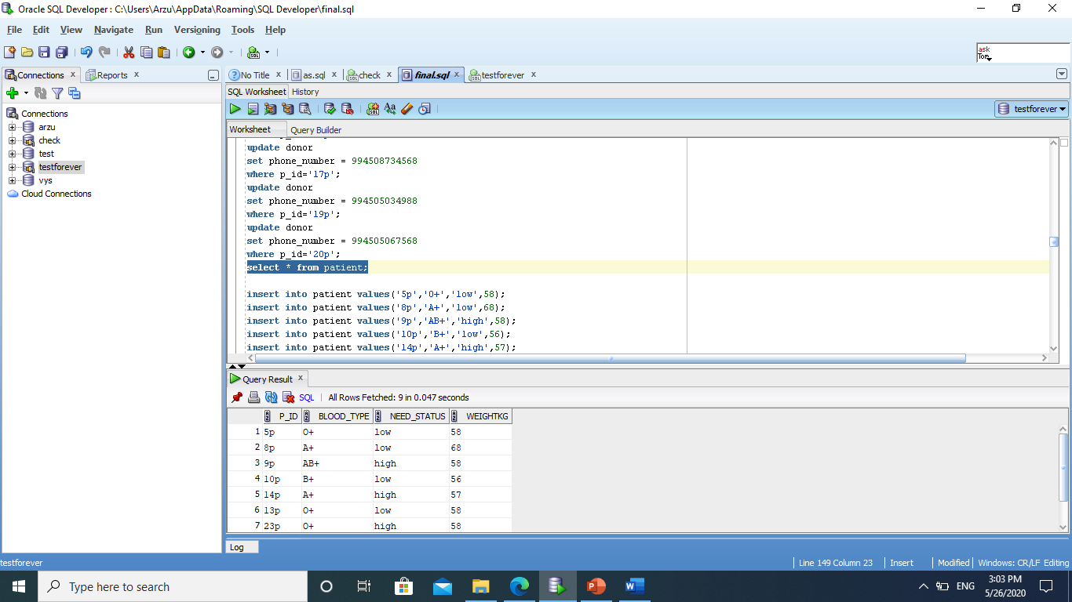

insert into nurse values('1p',5);

select * from nurse;

delete from nurse where p_id='1p';

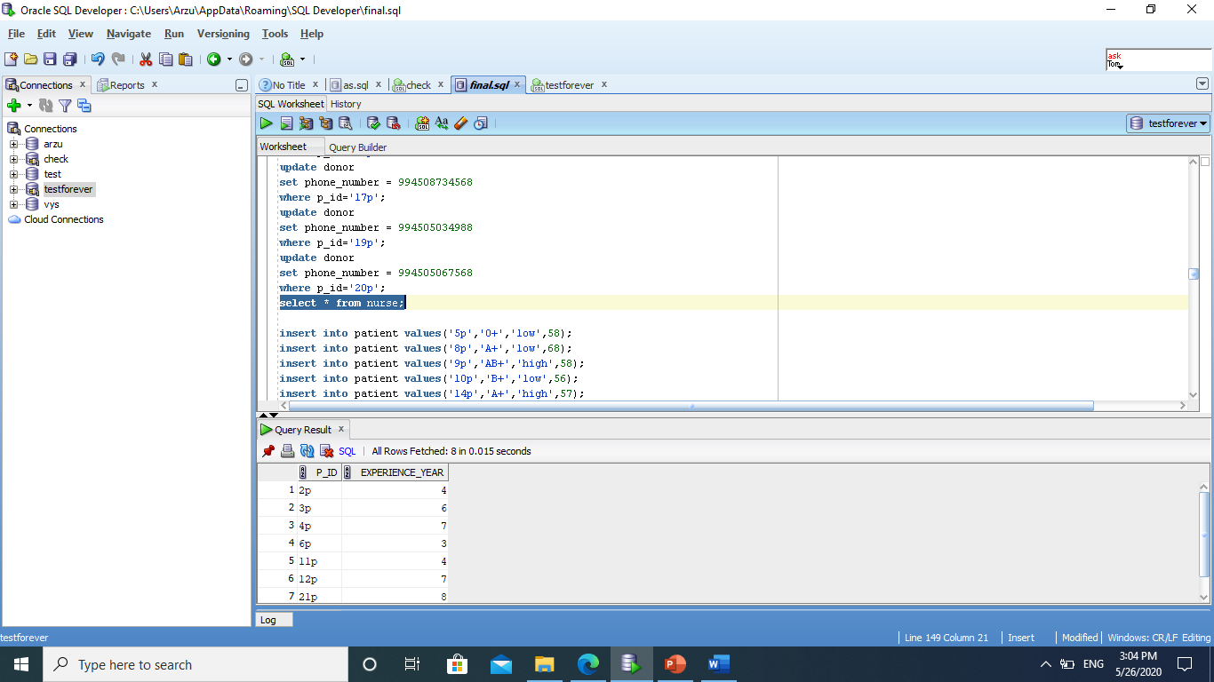

insert into pre_exam values('ex1',15.49974937,98.65776,'120/80',70);

insert into pre_exam values('ex2',14.9784923,98.3138184810,'110/70',75);

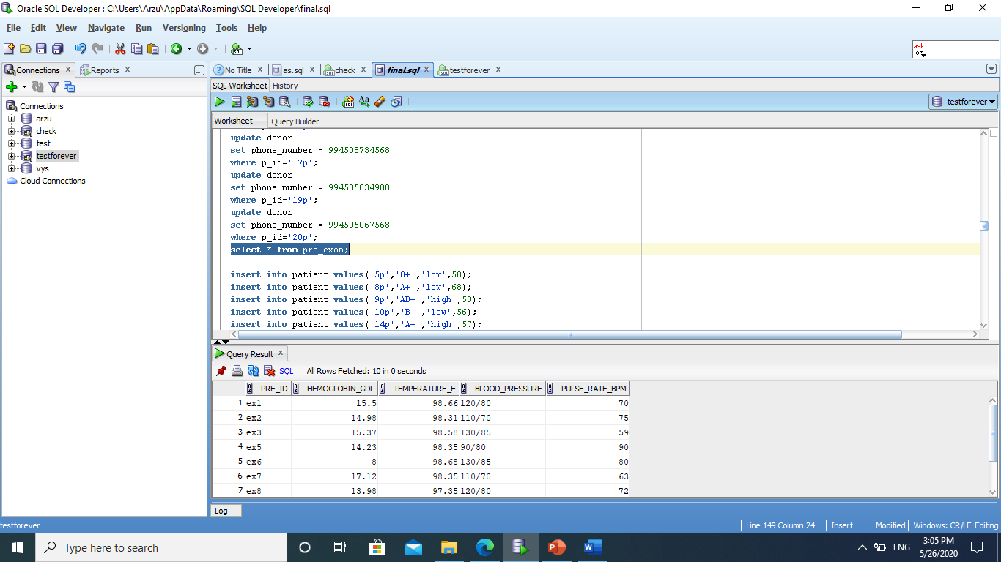

insert into donation_types values('blood',56);

insert into donation_types values('platelets',7);

insert into donation values('d1','4p','ex1','1p',946.2,'power red');

insert into donation values('d2','7p','ex2','1p',946.2,'power red');

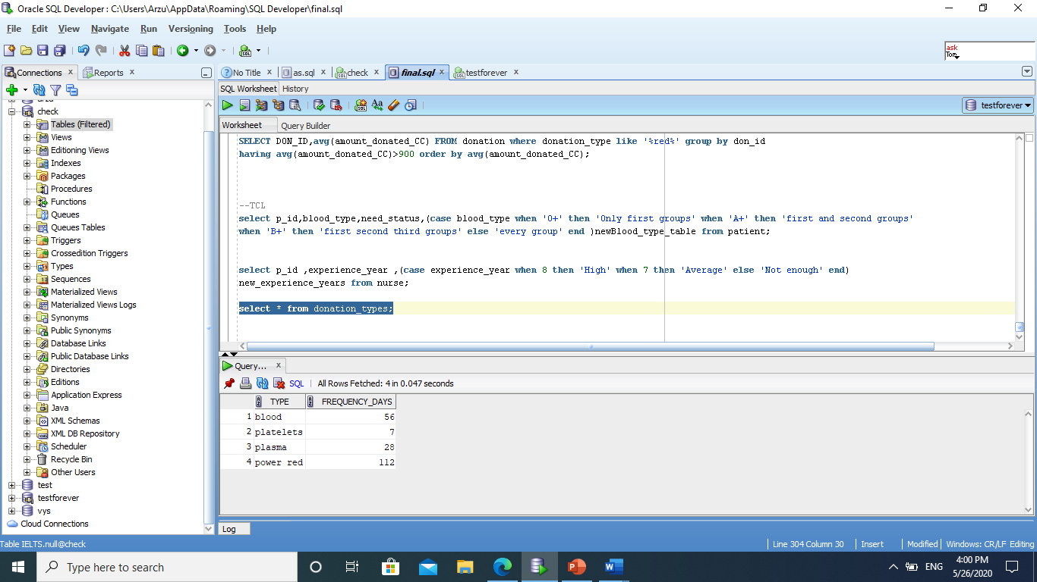

***--Select Commands***

select nurse from donation where donation_type='power red';

select blood_type from donor where weightkg>60;

select blood_pressure from pre_exam where pulse_rate_bpm>63;

***--Retrieving and Restricting Data***

select first_name || ' ' || last_name as "full name" from allpeople;

select p_id from nurse where experience_year>3;

select first_name from allpeople where p_id='2p';

select p_id,phone_number,donationDate from donor order by donationDate desc

fetch first 2 rows only;--**Latest 2 donors**

***--Joins--***

**--Available donors and their blood_types for patients**

select d.p_id,d.blood_type,d.donationdate,p.need_status,p.p_id,p.blood_type from donor d inner join patient p on d.blood_type=p.blood_type

and p.need_status='high';

**--see names of nurses and their details**

select * from allpeople inner join nurse on allpeople.p_id=nurse.p_id;

**--which donation belongs to which donor**

select d.don_id,d.p_id,donor.p_id,d.donation_type,a.first_name,a.last_name from donation d join donor on donor.p_id=d.p_id join allpeople a on donor.p_id=a.p_id;

**--blood characteristics belongs which donors**

select * from pre_exam join donation using(pre_id);

select * from patient;

***--Subqueries--***

**--Patients who have the same blood_type with patient who has '5p'id**

select * from patient

where blood_type=

(select blood_type from

patient where p_id='5p');

**--Shows all data of donors who donated blood after donor with id '4p'--**

select * from donor

where donationdate>

(select donationdate from donor where p_id='4p');

**--Identify who can donate a blood if 30 days has passed from previous donation**

select p_id,blood_type,donationdate from donor where (sysdate-donationdate)>30;

**--shows hemoglabin amounts of donation which are more than amount of hemoglabin in donation number 'ex6'**

select * from pre_exam where hemoglobin_gDL>(select hemoglobin_gDL from pre_exam where pre_id='ex6');

***--views--***

**--make a view from donation table where donation_type is blood--**

create view donationview

as select don_id,p_id,nurse from donation where donation_type='blood';

describe donationview;

select * from donationview;

**--make a view from patient table where need for blood is high--**

create view patientview

as select p_id,blood_type from patient where need_status='high';

select * from patientview;

--

create sequence donor_seq

increment by 10

start with 10

maxvalue 100

cycle

nocache;

select * from donor_seq;

--

create public synonym donors

for ielts.donor;

***--Single Row Functions***

select last_name,

upper(concat(substr(last_name,1,5),'_zu'))

from allpeople

where age=21;

select avg(pulse_rate_BPM) from pre_exam ;

select p_id,blood_type,phone_number ,(sysdate-donationdate)/7 as weeks

from donor

where blood_type='O+';

***--Group Functions***

select avg(pulse_rate_BPM) from pre_exam group by pre_id;

select pre_id,avg(TEMPERATURE_F) from pre_exam group by pre_id having max(hemoglobin_gDL)>14;

SELECT DON_ID,avg(amount_donated_CC) FROM donation where donation_type like '%red%' group by don_id

having avg(amount_donated_CC)>900 order by avg(amount_donated_CC);

**--TCL**

select p_id,blood_type,need_status,(case blood_type when 'O+' then 'Only first groups' when 'A+' then 'first and second groups'

when 'B+' then 'first second third groups' else 'every group' end )newBlood_type_table from patient;

select p_id ,experience_year ,(case experience_year when 8 then 'High' when 7 then 'Average' else 'Not enough' end)

new_experience_years from nurse;

***--Commit,rollback,savepoint***

insert into allpeople values('p30','Sevda','Hesenova',30);commit;

update allpeople set first_name='Sevgi' where p_id='p30';

select * from allpeople;

savepoint A;

insert into allpeople values('p32','Hesen','Hesenli',30);

savepoint B;

rollback to B;

***References:***

<https://www.geeksforgeeks.org/dbms/>

<https://app.sqldbm.com/SQLServer/BringDb/>

<https://www.redcross.org/about-us.html>